# Analyzing Discharge Changes in the Tigris and Euphrates Rivers (1979-2022): The Role of Damming and Drought

Mohsen Bakhtiari a, b, Najmeh Neysani Samany a*, Ali Darvishi Boloorani a

*a Department of Remote Sensing and GIS, Faculty of Geography, University of Tehran, Tehran, Iran*

*b* *General Department of Natural Resources and Watershed Management of Alborz Province, Karaj, Iran*

*Corresponding author:* [*nneysani@ut.ac.ir*](mailto:nneysani@ut.ac.ir)

**Abstract**

The Tigris and Euphrates Basin (TEB) are currently confronting unprecedented water resource challenges due to extensive dam construction and escalating impacts of climate change. This study investigates discharge variations in these rivers over the period from 1979 to 2022, aiming to reveal the relative contributions of damming and prolonged droughts as one of the main consequences of climate change in the TEB. Using daily discharge data from 12 sampling stations situated close (proximal) to major dams and 12 stations located far (distal) downstream of dams, complemented by monthly Palmer Drought Severity Index (PDSI), we applied a combination of time series analysis, correlation analysis, change point detection, and comparative assessments of pre- and post-damming periods. Our results reveal significant reductions in average discharge, alterations in flow regimes, and a strong correlation between drought severity and river flow. Distinct differences emerged between proximal and distal stations to dams. Proximal stations to dams exhibited abrupt decreases of water discharge corresponding with major dam operations, while distal stations displayed more gradual declines influenced by both damming and drought phenomena. Change point analysis pinpointed sudden discharge declines at proximal stations aligned with dam operations, whereas distal stations reflected a progressive decline shaped by combined damming and drought factors. The lower correlation of daily, monthly and seasonal discharge trends at proximal stations, regarding the rather homogeneous impact of drought, can be attributed to damming. The higher correlation of seasonal discharge trends compared to annual discharges at distal stations is attributed to the stronger correspondence between discharge and precipitation regimes over seasonal rather than annual timescales. The findings suggest that while damming has produced immediate and pronounced impacts on local hydrology, drought exerts a pervasive basin-wide influence, exacerbating downstream water scarcity. The study underscores the necessity for integrated water management strategies considering both infrastructural developments and climate variability to address future water security in TEB.

**Key words**: Tigris and Euphrates rivers, discharge, drought, damming, climate change.

1. **Introduction**

Dams fundamentally alter the natural flow regime of rivers by acting as physical barriers that impound water, thereby creating reservoirs (Petts, 1984; Shiklomanov, 1997; Graf, 2006). This impoundment inherently disrupts the natural patterns of river flow, leading to what is known as flow regulation (Ward & Stanford, 1995). Flow regulation involves the storage of water during periods of high discharge, such as wet seasons or flood events, and the subsequent release of the stored water during periods of low discharge, such as dry seasons or droughts (Wen et al., 2011; Lu et al., 2021). The primary aim of this regulation is to meet various human demands, including water supply for home and industrial uses (Adamo et al., 2020), irrigation for agriculture, the generation of hydroelectric power, and the mitigation of flood risks (Kibaroglu & Scheumann, 2013). Dams typically reduce the peak flood discharge downstream by effectively storing a portion of the floodwaters within the reservoir. Conversely, during dry seasons, dams can increase the discharge downstream by releasing the water that was stored during wetter periods, which can lead to a more homogenized flow regime throughout the year. However, the extent of these changes depends largely on several factors, including the dam’s size and reservoir capacity, the operational rules that prioritize objectives such as hydropower generation or irrigation supply, and the broader water management strategy adopted within the river basin (Graf, 2006, Voss et al., 2013). Furthermore, dams tend to flatten the natural variability of river discharge over time (Shiklomanov, 1997). In addition to these seasonal or event-based changes, dams can also introduce unnatural short-term fluctuations in discharge. These rapid changes in river flow are frequently driven by operational needs, especially in the case of hydroelectric dams, where water releases are adjusted to meet peak electricity demands. Such modifications can significantly alter the timing of naturally occurring high and low flow periods. These shifts can have profound implications for the ecological cues that many aquatic and riparian species rely upon for critical life cycle events, including migration, spawning, and germination. (Ward & Stanford, 1995; Eiriksdottir et al., 2017; Kamidis et al., 2021).

The Tigris and Euphrates Basin (TEB), a region of immense historical and ecological significance in the Middle East, have sustained human civilizations for millennia (Altinbilek, 2004; Zargar & Abbasi Alamooti, 2023). These rivers, originating in Turkey and flowing through Syria and Iraq to the Persian Gulf, are the lifeblood of an arid and semi-arid landscape, supporting agriculture, providing essential water supplies, and sustaining diverse ecosystems (Issa et al., 2013). In recent decades, however, the basin has experienced increasing water stress due to large-scale damming projects, particularly within Turkey, and the growing threat of climate change manifested as prolonged and intensified droughts (UN-ESCWA, 2013; Ozguler & Yıldız, 2020). The Southeastern Anatolia Project (GAP), initiated by the Turkish government, represents a massive undertaking involving the construction of numerous dams and hydroelectric power plants on both rivers (Unver, 1997; Hussein & Mohamed, 2021). Key structures such as the Atatürk Dam on the Euphrates and the Ilisu Dam on the Tigris have significantly altered the natural flow regimes of these rivers, leading to concerns about water availability and quality in downstream Syria and Iraq (Beaumont, 1978). While Turkey emphasizes the benefits of these projects for energy production and irrigation within its borders, the scale of these interventions has raised significant geopolitical and environmental issues in the region (Oktav, 2017; Luan et al., 2025). Iraq, being the furthest downstream riparian state, has consistently claimed significant reductions in its historical water supply from both the Tigris and Euphrates rivers since the 1970s, coinciding with the intensification of Turkish dam construction. The magnitude of the reported flow reductions is substantial, although estimates can vary across different study areas and time periods. For the Euphrates River, reductions of 40% or even greater in discharge have been reported following the completion of major dams like the Atatürk. Similarly, the flow of the Tigris River is anticipated to decrease significantly, potentially by as much as 50% of its historical average, once all planned Turkish dams within the GAP project become fully operational. Beyond the overall reduction in water quantity, the seasonal flow patterns of both rivers have also been demonstrably altered. These alterations typically involve a reduction in the magnitude of peak flows that historically occurred during the spring months due to snowmelt and rainfall in the upper catchments. The extensive damming has also led to instances of significant deviations from historical flow norms, including concerns about potential flow cessation in the Euphrates River within Iraq. Some projections suggest that the Euphrates could face the risk of drying up within Iraqi territory by the year 2040, a dire consequence attributed to a combination of upstream damming and the increasing impacts of climate change and drought on regional water availability. The reduced water flow, particularly the decrease in seasonal flooding, has had a devastating impact on the vital Iraqi marshes located in the lower reaches of the river basins, leading to their significant destruction and the disruption of the unique ecosystems and livelihoods they once supported (Issa et al., 2013). Dam construction and increasing regional droughts have jointly altered the hydrological balance, reducing downstream water availability and contributing to the desiccation of marshes and wetlands (Beaumont, 1978; Unver, 1997; El-Fadel et al., 2002; UN-ESCWA, 2013; Al-Ansari et al., 2019; Azizi & Leandro, 2025), which in turn become active dust sources as wind erodes exposed soils and triggers dust storm events (Bakhtiari et al., 2021; Darvishi Boloorani et al., 2021).

This study analyzes 44 years (1979–2022) of discharge changes in the Tigris and Euphrates rivers to assess the respective and combined impacts of upstream damming and climate-induced drought. Using hydrological and statistical methods on daily discharge data from 12 proximal stations near major dams and 12 distal downstream stations, along with monthly Palmer Drought Severity Index (PDSI) data, the study quantifies how these factors have altered river flow regimes. Understanding their interplay is crucial for sustainable water management and mitigating potential conflicts in this water-scarce and politically sensitive basin.

1. **Material and Methods** 
   1. **Study Area**

The Tigris and Euphrates rivers originate in the eastern Anatolian highlands of Turkey and flow southeast through Syria and Iraq before converging at Al-Qurnah to form the Arvand Rud (called Shatt al-Arab in Iraq), which drains into the Persian Gulf (Altinbilek, 2004; Kibaroglu & Scheumann, 2013). The basin’s elevation ranges from sea level to nearly 4000 m in the northern and northeastern highlands (Fig. 1), with precipitation and temperature largely controlled by altitude and latitude. The Tigris–Euphrates Basin (TEB) exhibits sharp climatic gradients—from humid mountain headwaters to arid and semi-arid plains. These rivers provide vital freshwater for agriculture, ecosystems such as the Mesopotamian Marshes, and dense human populations (Issa et al., 2013; Al-Ansari et al., 2018).

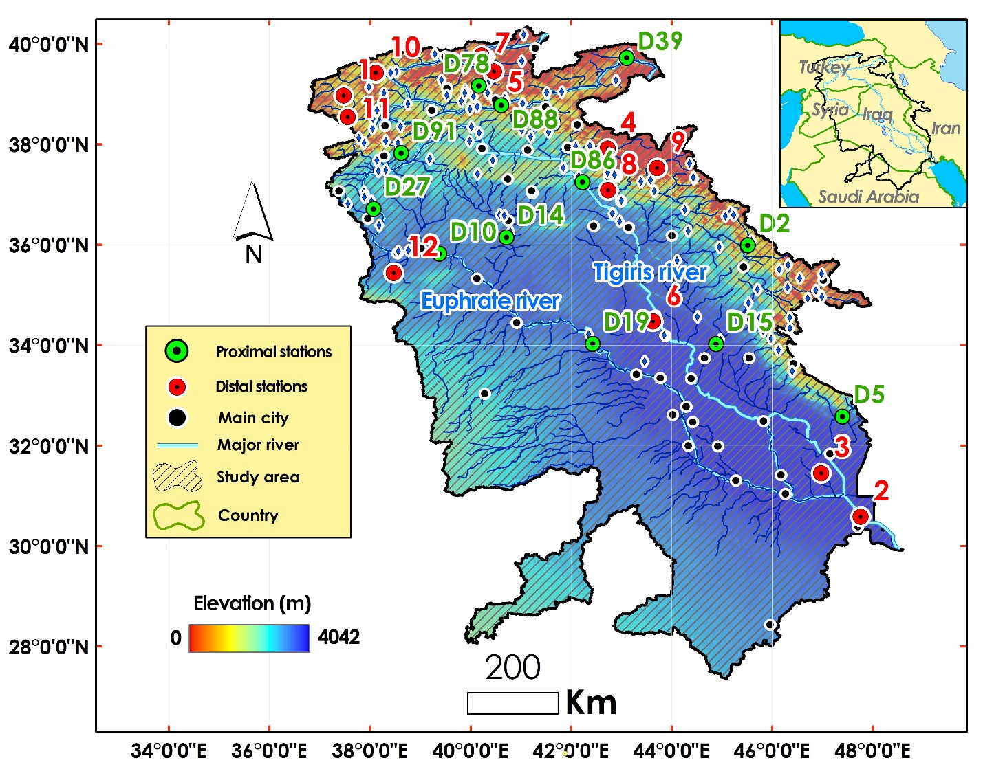

Fig. 1. The Tigris and Euphrates Basins (TEB). D is referring to the operational dams.

* 1. **Datasets**

Dam characteristics, including construction year, storage volume, and operational status, are summarized in Table 1 and were extracted from the Global Reservoir and Dam Database (GRanD), which compiles reservoirs exceeding 0.1 km³ capacity (Lehner et al., 2011). Two main datasets were used in this study: daily discharge and monthly Palmer Drought Severity Index (PDSI), covering 1979–2022, to analyze discharge variability and the effects of damming and drought.

**Daily discharge:** The gridded daily discharge dataset provides a modeled time series of river network discharges generated using the open-source hydrological model LISFLOOD, designed for hydrological, flood, and drought analyses (Harrigan et al., 2020). Data were obtained from 24 stations (12 proximal and 12 distal) along the Tigris and Euphrates rivers (Fig. 1). Proximal stations were selected near major dams to assess the immediate effects of dam operations, while distal stations—located farther downstream—capture broader climatic and tributary influences. The daily resolution enables assessment of both short-term variability and long-term discharge trends.

**Monthly palmer drought severity index (PDSI):** Monthly Palmer Drought Severity Index (PDSI) values were obtained for the Tigris–Euphrates Basin (TEB). PDSI integrates temperature, precipitation, and potential evapotranspiration in a soil–water balance model to quantify drought severity and persistence (Dai, 2011; Abatzoglou et al., 2018). This index was used to evaluate long-term drought impacts on river discharge and to compare drought sensitivity between stations near and far from dam infrastructure.

Table 1- The attributes of the selected dams in TEB (Lehner et al., 2011)

|  |  |  |  |  |  |  |  |  |
| --- | --- | --- | --- | --- | --- | --- | --- | --- |
| **ID** | **Code** | **Name** | **River** | **Basin** | **Country** | **Operation year** | **Functions** | **Volume (MCM)** |
| **1** | D19 | Haditha | Euphrates | Euphrates | Iraq | 1987 | Irrigation/ Hydro Power | 8280 |
| **2** | D39 | Yazici | Altincayir | Euphrates | Turkey | 2009 | Irrigation | 196 |
| **3** | D88 | Lower Kaleköy | Murat | Euphrates | Turkey | 2019 | Hydro Power | 516.5 |
| **4** | D27 | Karkamis | Euphrates | Euphrates | Turkey | 2000 | Hydro Power/ Flood Control | 160 |
| **5** | D91 | Sırımtaş | Birimşe | Euphrates | Turkey | 2013 | Hydro Power | 60 |
| **6** | D78 | Yedisu | Peri | Euphrates | Turkey | 2012 | Hydro Power | 5 |
| **7** | D86 | Ilısu | Tigris | Tigris | Turkey | 2018 | Irrigation/ Hydro Power/ Flood Control | 10410 |
| **8** | D10 | Baath | Euphrates | Euphrates | Syria | 1987 | Irrigation/ Hydro Power/ Flood Control | 90 |
| **9** | D14 | Bassel Al Assad | Khabur | Euphrates | Syria | 2001 | Irrigation | 605 |
| **10** | D15 | Hamrin | Diyala | Tigris | Iraq | 1981 | Irrigation/ Flood Control | 2450 |
| **11** | D2 | Sardasht | Lesser_Zab | Tigris | Iran | 2017 | Irrigation/ Hydro Power | 387 |
| **12** | D5 | Dwairej | Dwairej | Tigris | Iran | 2013 | Irrigation | 205 |

* 1. **Methodology**

This study analyzed 12 proximal and 12 distal stations along the Tigris and Euphrates rivers to investigate discharge variations and assess the respective influences of damming and drought (Fig. 2). Analytical and statistical techniques were applied to datasets covering 1979–2022.

**Time Series Analysis (TSA):** Daily discharge data were examined using time series analysis to identify long-term flow patterns and regime shifts. TSA methods capture relationships between a time series and its lagged values, revealing temporal dependencies and hydrological interrelations (Haas et al., 2009; Shamseddin & Elmeski, 2022; Fu et al., 2024). The Breaks for Additive Season and Trend (BFAST) model decomposes time series into trend, seasonal, and residual components, effectively detecting structural changes in discharge (Richter et al., 1996; Piwowar & LeDrew, 2002; Verbesselt et al., 2010; Geng et al., 2019; Li et al., 2022; Mendes et al., 2022). These methods were used to quantify variations in average flow and identify significant change periods across the 44-year record for both station groups.

**Correlation analysis:** To evaluate drought–discharge interactions, Pearson’s correlation coefficients were computed between monthly discharge and PDSI values (Nielsen, 2002; Dai, 2011). This analysis assessed the strength and direction of linear relationships, indicating how drought conditions influence river flow at varying proximities to major dams.

**Change Point and Comparative Analyses:** Change point analysis was employed to detect statistically significant shifts in mean discharge and relate them to dam operation timelines, including the Atatürk (early 1990s) and Ilisu (2019) dams (Kibaroglu & Scheumann, 2013). Discharge characteristics before and after dam operation were compared to evaluate hydrological alterations. Differences in magnitude, seasonal variability, and drought correlations between proximal and distal stations helped distinguish localized dam effects from broader climatic influences.

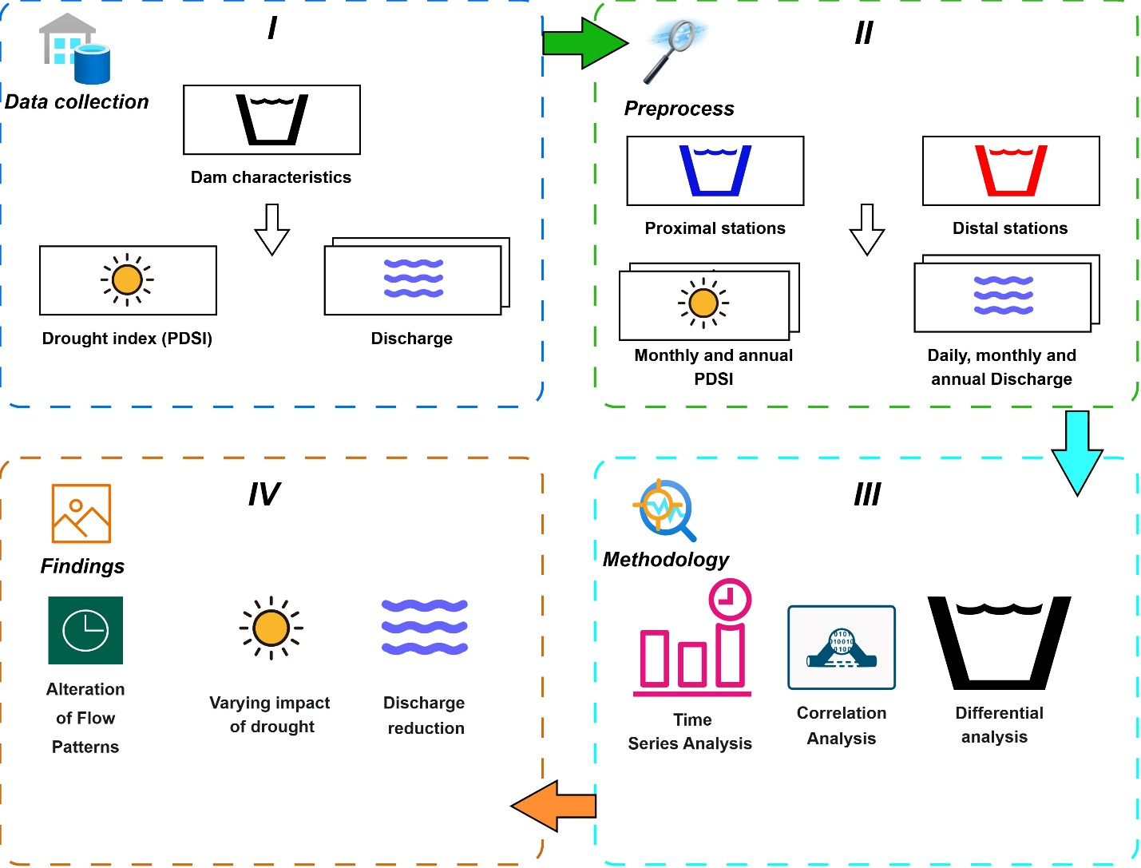

Fig. 2. Flowchart of general steps of the study

1. **Results**
   1. **Annual changes of river discharge and drought**

Figures 3 and 4 illustrate annual changes of discharge (m3/s) and drought for the 24 stations of main dams on the TEB during 1979 to 2022, respectively. PDSIs were categorized into 8 classes from extreme dry (highest red vertical dash line) to extreme wet times (highest blue vertical dash line). The PDSI values between -1 and 1 are no presented in the figures.

|  |  |  |
| --- | --- | --- |
|  |  |  |
|  |  |  |
|  |  |  |
|  |  |  |

Fig. 3. Annual discharge (m3/s) and PDSI changes of proximal stations from 1979 to 2022. PDSIs were categorized into 8 classes from extremely drought (highest red vertical dash line) to extremely wet (highest blue vertical dash line). 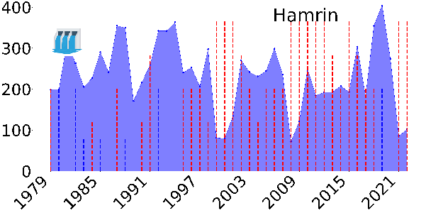 shows year of dam operation.

|  |  |  |
| --- | --- | --- |
|  |  |  |
|  |  |  |
|  |  |  |
|  |  |  |

Fig. 4. Annual discharge (m3/s) and PDSI changes of the distal stations during 1979 to 2022.

Average discharge values of proximal stations before and after dam constructions are compared in Fig. 5-a. A Considerable reduction of discharge was observed across all those stations during the second period. Variation of proximal station discharges within the 2 periods showed an increment in average discharge fluctuation (m3/s) for most stations (Fig. 5-b).

|  |  |
| --- | --- |
|  |  |

Fig. 5. (a) Average discharges (m3/s) and (b) discharge fluctuations (m3/s) for the close stations to dams for the TEB rivers before and after dam constructions.

* 1. **Monthly discharge trending**

To perform flow trending, first, the Mann–Kendall test was implemented on the monthly discharge series at the proximal to dam stations. Then, trending was performed using the BFAST on the monthly discharge time series at stations with a trend. Monthly trends of proximal stations and the trend and seasonality components for those time series were provided (see Appendix Extended Figs. 9−10). Resultes revealed that 8 of the 12 proximal stations had a significant monthly flow trend between 1979 and 2022, with the exception of Khabour dam (Bassel Hafez al Assad dam) in northeastern Syria on the Euphrates River, the remaining stations had experineced a decreasing monthly trend.

Monthly trends of proximal stations from 1979 to the year of dam construction and two trending components, the trend and seasonality components of those time series, are available in Appendix (Extended Figs. 11−12). Only 2 stations, including Lower Kaleköy and Ilissu, showed a decreasing monthly flow trend during the period, while the remaining stations had no trend. Monthly trends of proximal stations during the year of dam construction to 2022 (see Appendix Extended Fig. 13) confirmed that 5 stations witnessed a decreasing monthly flow trend during the studied period. Trend and seasonality components for those monthly discharge time series after dam construction are presented in Appendix (see Appendix Extended Fig. 14).

Monthly trends of distal to dams stations during 1979 to 2022 and their corresponding trend and seasonality components (see Appendix Extended Figs. 15−16) shows that 10 stations verified a decreasing monthly flow trend during the period while the only 2 stations had no trend. More distal stations with trend compare to proximal stations during the same period could imply the more uniform impact of effective factors on discharge trend in distal dam stations.

* 1. **PSDI changes of close-dam and far-from-dam stations**

Average PDSI changes before and after dam construction, consistently shows lower (more negative) PDSI values after dam construction across all close-dam stations (Fig. 6- a), indicates an increase in drought severity downstream of the dams. Average values of PDSI for distal stations during 1979 to 2022 are shown in Fig. 6-b. Average PDSI of proximal stations during 1979- 2022, before and after dam constructions were -1.3, -0.50 and -2.10, respectively, while it was -0.82 for distal stations. Therefore, the PDIS changes directly implies a worsening of drought conditions, especially in downstream after dam constructions.

|  |  |
| --- | --- |
|  |  |

Fig. 6. Average PDSI values before (blue) and after (red) dam constructions for proximal (a) and distal (b) stations from 1979 to 2022.

* 1. **Relationship between annual discharge and PDSI**

To measure the correlation between drought and monthly discharge, the scatter plots of the two are presented separately for proximal stations during two periods, including before and after dam constructions (see Appendix Extended Fig. 17). R2 values for before and after dam constructions are calculated for all stations and are shown for better comparison as histograms in Fig. 7. In general, the correlation between PDSI and discharge in the period after construction of dams was higher than before (see Appendix Extended Fig. 19) because general trends of drought and monthly discharge after damming were decreasing. The only exception is the Sırımtaş station in the northwest of TEB because of its lower sensitivity of discharge to climatic and drought conditions, so that the correlations in the two periods did not differ much from each other. Stations with sensitivity to drought show greater correlation between discharge and drought after dam construction.

The scatter plots and the correlation between the monthly drought and discharge of distal stations, during the period 1979 to 2022 are given (see Appendix Extended Fig. 18). In general, the correlation between PDSI and monthly discharge for stations 1, 10, 11, and 12, which are in the northwest of TEB, are higher than for stations 2 and 3, which are in the southeast of TEB. This difference is noticeable, as stations 2 and 3 have a much higher average discharge than stations 1, 10, 11, and 12 (over 100 m³/s compared to about 20 m³/s), which are less affected by meteorological drought. Therefore, the correlation between discharge and drought is higher at stations with a lower average discharge, due to the higher impact of drought on discharge.

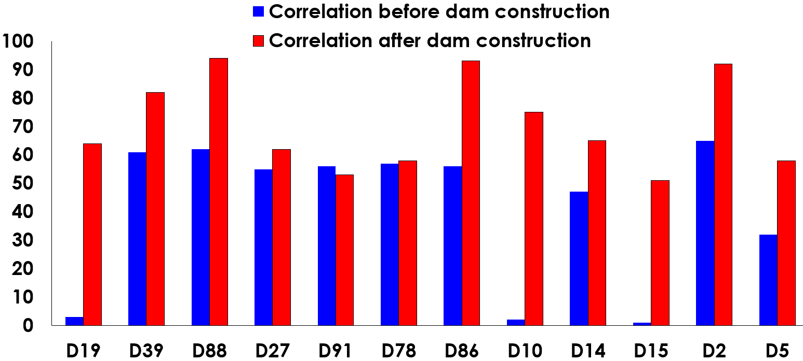

Fig. 7. Correlation between PDSI and discharge through before and after dam construction for 12 proximal stations to dams.

1. **Discussion**

The analysis of the discharge and PDSI time series from 1979 to 2022, revealed significant changes in the flow regimes of both the Tigris and Euphrates rivers, with distinct influences from damming and drought observed at both proximal and distal stations to dams in the whole Tigris and Euphrates basin.

**Discharge reduction:** A significant decline in average discharge was observed in both rivers across all stations, with the sharpest reductions at the 12 stations closest to the dams. Distal stations also showed decreases, though more gradual. The marked drop in downstream flow aligns with expected dam impacts—water impoundment, regulated releases, and increased evaporation. Notably, the Ilisu Dam station exhibited lower flows even before impoundment, likely due to construction-related disruptions. PDSI analysis indicates intensified drought conditions at proximal stations after dam operation, suggesting either a regional shift toward drier conditions or feedback from reduced surface water. Overall, the results highlight how dam operations amplify drought effects and reduce downstream water availability.

**Varying impact of drought:** River discharge showed a strong positive correlation with PDSI at both proximal and distal stations. The correlation was higher at distal stations and at proximal stations after dam construction, indicating stronger drought influence linked to climatic and damming effects. Near-dam stations displayed discharge patterns closely tied to dam operations, with climate impacts becoming more pronounced post-construction.

**Alteration of flow patterns:** The average slopes of monthly discharge trends for both proximal (close-to-dam) and distal (far-from-dam) stations across three periods—1979–2022, pre-dam (1979–year of construction), and post-dam (construction year–2022)—are shown in Fig. 8. The post-dam period exhibits a steeper negative slope at proximal stations, reflecting a stronger reduction in discharge downstream of dams. Although both station groups show similar slope magnitudes, distal stations have a higher number of valid discharge trends over the long-term record, likely due to the extended data period.

Damming projects caused more immediate and pronounced alterations in flow regimes at proximal stations, including reduced peak flows and shifts in seasonal timing, making downstream flow prediction more difficult. Distal stations also showed seasonal changes, but these were moderated by tributary inputs and regional climate influences. Change point analysis confirmed earlier and more significant declines in mean discharge at proximal stations, coinciding with dam operation years, while distal stations showed delayed and smaller declines. Overall, the estimated percentage reduction in average annual discharge was substantially higher near dams than at distant stations (Fig. 8).

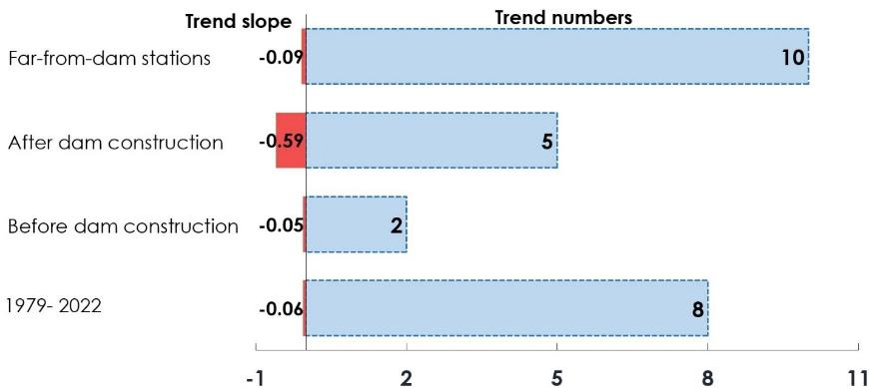

Fig. 8. Average slope and number of discharge trends in close- dam and far-dam stations

Pairwise correlation analysis between stations near and far from dams over the study period (1979–2022) revealed generally similar behaviour for both groups (Fig. 9). Detailed daily, monthly, seasonal, and annual discharge trends are provided in the Appendix (see Appendix Extended Figs. 1–8). Correlations were calculated using the Pearson coefficient to assess the influence of damming and drought on discharge variability.

|  |  |
| --- | --- |
|  |  |

Fig. 9. Distribution of pairwise correlation across daily, monthly, seasonal and annual temporal scales for close-dam (right) and far-dam stations (left).

The correlation of discharge trends increased from daily to annual scales at close-to-dam stations, while at far-from-dam stations the order was daily, monthly, annual, and seasonal. Far-dam stations showed stronger correlations at daily to seasonal scales, whereas annual correlations were higher near dams (Fig. 10). Lower short-term correlations at proximal stations reflect fluctuations from dam regulation, while higher seasonal correlations at distal stations indicate stronger links between discharge and precipitation. Stations D39 and D88 (northwest TEB) and stations 2 and 3 (southwest TEB) exhibited consistently high correlations due to similar climatic and topographic conditions, whereas stations 4 and 5 in the north showed weaker annual correlations under differing drought conditions. Overall, these results suggest that after dam construction, discharge variability near dams became more influenced by regulated releases than by local climate, while distal flows remained more climate-driven.

|  |  |
| --- | --- |
| (a) | (b) |

Fig. 10. The daily, monthly, seasonal and annual discharge correlation matrices for proximal (a) and distal (b) stations.

The radar chart (Fig. 11) compares normalized average discharge, PDSI, and their correlations for selected close-dam stations before and after dam construction. While discharge changes are subtle, correlations between discharge and PDSI increased for most stations, and PDSI values decreased sharply. These shifts suggest altered hydrological responses to drought following dam operation.

|  |  |
| --- | --- |
|  | 1 is the average discharge before dam construction  2 is the average discharge after dam construction  3 is the correlation of discharge and PDSI before dam construction  4 is the correlation of discharge and PDSI after dam construction  5 is the average PDSI before dam construction  6 is the average PDSI after dam construction |

Fig. 11. Radar chart shows average discharges and PDISs as well as their correlations for close-to -dam stations thorough before and after dam construction.

Results from proximal and distal stations reveal distinct hydrological responses in the TEB basin. Close-to-dam stations show sharper discharge reductions and immediate seasonal flow alterations, closely aligned with dam operation dates, confirming strong local impacts of dam regulation. Far-to-dam stations also experienced declining discharges and altered seasonality but with more gradual changes and stronger correlations with PDSI, indicating dominant climatic influences. The delayed and weaker response downstream suggests buffering effects from tributary inflows and local water management. Overall, damming has created localized zones of major hydrological alteration, while climate change exerts broader regional effects across the basin. These combined impacts underscore the need for integrated water management that accounts for both dam-induced and climatic drivers. As shown in Fig. 12, average discharge decreased after construction for all dam types—hybrid, irrigation, and hydropower—with irrigation dams causing greater proportional reductions, though hydropower dams produced larger absolute decreases due to their storage volumes.

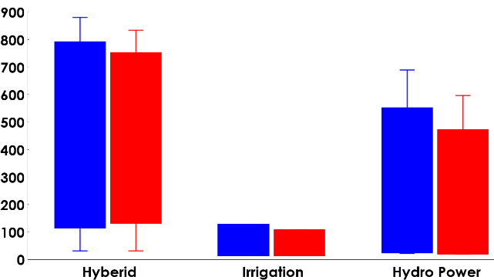

Fig. 12. Average discharge before (blue) and after (red) dam constructions for close-dam stations regarding the dam functions

**5. Conclusion**

This study analysed daily discharge data from close- and far-dam stations alongside monthly PDSI records (1979–2022) to assess the impacts of damming and drought on the Tigris and Euphrates rivers. Results show that dam operations cause immediate and substantial reductions in discharge and alter seasonal flow patterns near the dams, while drought exerts a more widespread influence across the basin. The combined effects of damming and climate variability have contributed to a significant decline in water resources, exacerbating downstream water scarcity. Differences between close- and far-dam stations highlight the spatially heterogeneous impacts of anthropogenic and climatic pressures. These findings underscore the need for integrated water management strategies and regional cooperation among riparian countries to mitigate adverse effects on river flow, ecosystems, and communities. Future research should focus on hydrological modeling of dam operations and drought impacts to improve sustainable water resource management in this arid and semi-arid region.

**Acknowledgements:** This work was supported by the Iran National Science Foundation (INSF) under project No. 402069. The authors also thank the General Department of Natural Resources and Watershed Management of Alborz Province for their valuable support.

**References**

Abatzoglou, J. T., Dobrowski, S. Z., Parks, S. A., & Hegewisch, K. C. (2018). TerraClimate, a high-resolution global dataset of monthly climate and climatic water balance from 1958–2015. *Scientific data*, *5*(1), 1-12.

Adamo, N., Al-Ansari, N., & Sissakian, V. (2020). How dams can affect freshwater issues in the Euphrates-Tigris basins. *Journal of Earth Sciences and Geotechnical Engineering*, *10*(1), 43-76.

Al-Ansari, N., AlJawad, S., Adamo, N., Sissakian, V. K., Laue, J., & Knutsson, S. (2018). Water quality within the Tigris and Euphrates catchments. *Journal of Earth Sciences and Geotechnical Engineering*, *8*(3), 95-121.

Al-Ansari, N., Jawad, S., Adamo, N., & Sissakian, V. (2019). Water quality and its environmental implications within Tigris and Euphrates rivers. *Journal of earth sciences and geotechnical engineering*, *9*(4), 57-108.

Altinbilek*, D. (2004). Development and management of the Euphrates–Tigris basin. *International Journal of Water Resources Development*, *20*(1), 15-33.

Azizi, M. A., & Leandro, J. (2025). Factors Affecting Transboundary Water Disputes: Nile, Indus, and Euphrates–Tigris River Basins. *Water (20734441)*, *17*(4).

Bakhtiari, M., Boloorani, A. D., Kakroodi, A. A., Rangzan, K., & Mousivand, A. (2021). Land degradation modeling of dust storm sources using MODIS and meteorological time series data. *Journal of Arid Environments*, *190*, 104507.

Beaumont, P. (1978). The Euphrates River—An international problem of water resources development. *Environmental Conservation*, *5*(1), 35-43.

Boloorani, A. D., Papi, R., Soleimani, M., Karami, L., Amiri, F., & Samany, N. N. (2021). Water bodies changes in Tigris and Euphrates basin has impacted dust storms phenomena. *Aeolian Research*, *50*, 100698.

Dai, A. (2011). Characteristics and trends in various forms of the Palmer Drought Severity Index during 1900–2008. *Journal of Geophysical Research: Atmospheres*, *116*(D12).

Eiriksdottir, E. S., Oelkers, E. H., Hardardottir, J., & Gislason, S. R. (2017). The impact of damming on riverine fluxes to the ocean: A case study from Eastern Iceland. *Water Research*, *113*, 124-138.

El‐Fadel, M., Sayegh, Y. E., Ibrahim, A. A., Jamali, D., & El‐Fadl, K. (2002). The Euphrates–Tigris Basin: A case study in surface water conflict resolution. *Journal of Natural Resources and Life Sciences Education*, *31*(1), 99-110.

Fu, Y., Zhu, Z., Liu, L., Zhan, W., He, T., Shen, H., ... & Ao, Z. (2024). Remote sensing time series analysis: A review of data and applications. *Journal of Remote Sensing*, *4*, 0285.

Geng, L., Che, T., Wang, X., & Wang, H. (2019). Detecting spatiotemporal changes in vegetation with the BFAST model in the Qilian Mountain region during 2000–2017. Remote Sensing, 11(2), 103.

Graf, W. L. (2006). Downstream hydrologic and geomorphic effects of dams: Case studies from the United States. *Geomorphology*, *79*(3-4), 264-283.

Haas, E. M., Bartholomé, E., & Combal, B. (2009). Time series analysis of optical remote sensing data for the mapping of temporary surface water bodies in sub-Saharan western Africa. *Journal of Hydrology*, *370*(1-4), 52-63.

Harrigan, S., Zsoter, E., Alfieri, L., Prudhomme, C., Salamon, P., Wetterhall, F., ... & Pappenberger, F. (2020). GloFAS-ERA5 operational global river discharge reanalysis 1979–present. *Earth System Science Data Discussions*, *2020*, 1-23.

Hussein, O. A., & Mohamed, K. (2021). Legal Rights of International Water Resources: A Case of Tigris and Euphrates Rivers. *International Journal of Law, Government and Communication*, *6*(22), 130-137.

Issa, I. E., Al-Ansari, N. A., Sherwany, G., & Knutsson, S. (2013). Trends and future challenges of water resources in the Tigris–Euphrates Rivers basin in Iraq. Hydrology and Earth System Sciences Discussions, 10(12), 14617-14644.

Kamidis, N., Koutrakis, E., Sapounidis, A., & Sylaios, G. (2021). Impact of river damming on downstream hydrology and hydrochemistry: The case of lower Nestos River catchment (NE. Greece). Water, 13(20), 2832.

Kibaroglu, A., & Scheumann, W. (2013). Turkey's water policy and the Southeastern Anatolia Project (GAP). In *Water policy in Turkey* (pp. 1-20). Springer.

Lehner, B., Liermann, C. R., Revenga, C., Vörösmarty, C., Fekete, B., Crouzet, P., ... & Robertson, J. C. (2011). Global reservoir and dam (grand) database. *Technical Documentation, Version*, *1*, 1-14.

Li, J., Li, Z. L., Wu, H., & You, N. (2022). Trend, seasonality, and abrupt change detection method for land surface temperature time-series analysis: Evaluation and improvement. *Remote Sensing of Environment*, *280*, 113222.

Lu, X. X., & Chua, S. D. X. (2021). River discharge and water level changes in the Mekong River: Droughts in an era of mega‐dams. Hydrological Processes, 35(7), e14265.

Luan, W., Li, X., Kuang, W., Su, J., Xue, H., Zhang, K., ... & Li, G. (2025). Quantitative Assessment of the Water Stress in the Tigris–Euphrates River Basin Driven by Anthropogenic Impacts. *Remote Sensing*, *17*(4).

Mendes, M. P., Rodriguez-Galiano, V., & Aragones, D. (2022). Evaluating the BFAST method to detect and characterise changing trends in water time series: A case study on the impact of droughts on the Mediterranean climate. *Science of The Total Environment*, *846*, 157428.

Nielsen, A. A. (2002). Multiset canonical correlations analysis and multispectral, truly multitemporal remote sensing data. IEEE transactions on image processing, 11(3), 293-305.

Oktav, Ö. Z. (2017). Turkey’s water policy in the Euphrates-Tigris basin. *Environmental change and human security in Africa and the Middle East*, 239-255.

Ozguler, H., & Yıldız, D. (2020). Consequences of the droughts in the Euphrates-Tigris Basin. International Journal of Water Management and Diplomacy, 1(1), 29-40.

Petts, G. E. (1984). Impounded rivers: perspectives for ecological management. *John Wiley & Sons*.

Piwowar, J. M., & LeDrew, E. F. (2002). ARMA time series modelling of remote sensing imagery: A new approach for climate change studies. *International Journal of Remote Sensing*, *23*(24), 5225-5248.

Richter, B. D., Baumgartner, J. V., Powell, J., & Braun, D. P. (1996). A method for assessing hydrologic alteration within ecosystems. *Conservation Biology*, *10*(4), 1163-1174.

Shamseddin, M. A., & Elmeski, H. A. (2022). Mapping dynamic changes in hydrological time series using the average directional index. International Journal of River Basin Management, 20(1), 67-78.

Shiklomanov, I. A. (1997). Assessment of water resources and water availability in the world. *Comprehensive Assessment of the Freshwater Re-sources of the World*.

UN-ESCWA, B. (2013). Inventory of shared water resources in western Asia: United nations economic and social commission for western Asia. *Federal Institute for Geosciences and Natural Resources, Beirut. Lebanon*.

Unver, I. O. (1997). Southeastern Anatolia Project (GAP). *International Journal of Water Resources Development*, *13*(4), 453-484.

Zargar, A., & Abbasi Alamooti, F. (2023). The security-environmental effect of the GAP project (Turkey) on downstream countries; considerations of International Law. *Quarterly Journal of West Asian Studies (Faṣlnāmah-i Gharb-i Asiyā)*, *1*(1), 73-85.

Ward, J. V., & Stanford, J. A. (1995). Ecological connectivity in alluvial river ecosystems and its disruption by flow regulation. *Regulated rivers: research & management*, *11*(1), 105-119.

Wen, L., Rogers, K., Ling, J., & Saintilan, N. (2011). The impacts of river regulation and water diversion on the hydrological drought characteristics in the Lower Murrumbidgee River, Australia. *Journal of Hydrology*, *405*(3-4), 382-391.

Verbesselt, J., Hyndman, R., Newnham, G., & Culvenor, D. (2010). Detecting trend and seasonal changes in satellite image time series. *Remote sensing of Environment*, *114*(1), 106-115.

Voss, K. A., Famiglietti, J. S., Lo, M., De Linage, C., Rodell, M., & Swenson, S. C. (2013). Groundwater depletion in the Middle East from GRACE with implications for transboundary water management in the Tigris‐Euphrates‐Western Iran region. *Water resources research*, *49*(2), 904-914.

**Appendix**

|  |
| --- |
|  |
|  |
| Extended Fig. 1. Daily discharge (m3/s) and of sampled proximal stations from 1979 to 2022. |
|  |
| Extended Fig. 2. Monthly discharge (m3/s) and of sampled proximal points from 1979 to 2022. |
|  |
| Extended Fig. 3. Seasonal discharge (m3/s) and of sampled proximal points from 1979 to 2022. |
|  |
| Extended Fig. 4. Annual discharge (m3/s) and of sampled proximal points from 1979 to 2022. |

|  |
| --- |
|  |
|  |
| Extended Fig. 5. Daily discharge (m3/s) and of sampled distal stations from 1979 to 2022. |
|  |
| Extended Fig. 6. Monthly discharge (m3/s) and of sampled distal points from 1979 to 2022. |
|  |
| Extended Fig. 7. Seasonal discharge (m3/s) and of sampled distal points from 1979 to 2022. |
|  |
| Extended Fig. 8. Annual discharge (m3/s) and of sampled distal points from 1979 to 2022. |

|  |  |  |
| --- | --- | --- |
|  |  |  |
| Trend= decreasing, Slope= -0.2147 | Trend= decreasing, Slope= -0.2147 | Trend= decreasing, Slope= -0.2147 |
|  |  |  |
| Trend= decreasing, Slope= -0.2147 | Trend= decreasing, Slope= -0.2147 | Trend= decreasing, Slope= -0.2147 |
|  |  |  |
| Trend= decreasing, Slope= -0.2147 | Trend= decreasing, Slope= -0.2147 | Trend= decreasing, Slope= -0.2147 |
|  |  |  |
| Trend= decreasing, Slope= -0.2147 | Trend= decreasing, Slope= -0.2147 | Trend= decreasing, Slope= -0.2147 |

Extended Fig. 9. The monthly discharge trend of the proximal stations during 1979 to 2022 using Mann–Kendall test. For stations with trend, two parameters including Trend (increasing or decreasing) and slope were presented.

|  |  |  |
| --- | --- | --- |
|  |  |  |
|  |  |  |
|  |  |  |
|  |  |  |
|  |  |  |
|  |  |  |

Extended Fig. 10. Trend and seasonality components of monthly discharge trending for proximal stations with trend.

|  |  |  |
| --- | --- | --- |
|  |  |  |
| No trend | No trend | Trend= decreasing, Slope= -0.0419 |
|  |  |  |
| No trend | No trend | No trend |
|  |  |  |
| Trend= decreasing, Slope= -0.060 | No trend | No trend |
|  |  |  |
| No trend | No trend | No trend |

Extended Fig. 11. The monthly discharge trend of the proximal stations during 1979 to the year of dam construction.

|  |  |
| --- | --- |
|  |  |
|  |  |

Extended Fig. 12. Trend and seasonality components of monthly discharge trending for proximal stations with trend during 1979 to the year of dam construction

|  |  |  |
| --- | --- | --- |
|  |  |  |
| Trend= decreasing, Slope= -0.2234 | Trend= decreasing, Slope= -0.0525 | No trend |
|  |  |  |
| No trend | No trend | No trend |
|  |  |  |
| Trend= decreasing, slope= -2.5034 | Trend= decreasing, slope= -0.1591 | No trend |
|  |  |  |
| Trend= decreasing, Slope= -0.00108 | No trend | No trend |

Extended Fig. 13. The monthly discharge trend of the proximal stations during the year of dam construction to 2022.

|  |  |  |
| --- | --- | --- |
|  |  |  |
|  |  |  |
|  |  |  |
|  |  |  |

Extended Fig. 14. Trend and seasonality components of monthly discharge trending for proximal stations with trend within the year of dam construction to 2022.

|  |  |  |
| --- | --- | --- |
|  |  |  |
| Trend= decreasing, Slope= -0.0002 | Trend= decreasing, Slope= -0.5163 | Trend= decreasing, Slope= -0.1591 |
|  |  |  |
| No trend | Trend= decreasing, Slope= -0.0037 | Trend= decreasing, Slope= -0.0863 |
|  |  |  |
| Trend= decreasing, Slope= -0.0077 | Trend= decreasing, Slope= -0. 0053 | No trend |
|  |  |  |
| Trend= decreasing, Slope= -0.0039 | Trend= decreasing, Slope= -0.0001 | Trend= decreasing, Slope= -0.0001 |

Extended Fig. 15. The monthly discharge trend of the distal stations during 1979 to 2022.

|  |  |  |
| --- | --- | --- |
|  |  |  |
|  |  |  |
|  |  |  |
|  |  |  |
|  |  |  |
|  |  |  |
|  |  |  |
|  |  |  |

Extended Fig. 16. Trend and seasonality components of monthly discharge trending for distal stations with trend within 1979 to 2022.

|  |  |  |
| --- | --- | --- |
|  |  |  |
|  |  |  |
|  |  |  |
|  |  |  |

Extended Fig. 17. The scatter plots showing the correlation between annual discharge and PDSI of proximal stations during 1979 to the year of dam construction (blue) and the year of dam construction to 2022 (red). X-axis and y- axis values show the annual PDSI and discharge, respectively.

|  |  |  |
| --- | --- | --- |
|  |  |  |
|  |  |  |
|  |  |  |
|  |  |  |

Extended Fig. 18. The scatter plots showing the correlation between annual discharge and PDSI of the distal stations during 1979 to 2022.

|  |  |
| --- | --- |
|  |  |

Extended Fig. 19. Correlation between average annual discharge and PDSI of the proximal stations before (blue) and after (red) dam construction (right) and distal stations during 1979 to 2022 (left). The relationship is stronger in proximal stations (R² = 0.56) than in distal ones (R² = 0.52), with a higher correlation after dam construction than before.